Nicolas Smith 11463982 Compilers Report

Introduction
The overall goal of this task was to create a Lexer Program that reads input from a file and identifies different tokens. This involves running a finite state machine that runs until a certain terminal token is reached.
The tokens it deals with are as follows:

Lpar : Left Parentheses
Rpar: Right Parentheses
Comma: Commas
id: String of numbers and characters a-z (upper and lower case).
Int: String of numeric characters.
String: Sequence of characters begins and ends with “
Error: For invalid characters.

Note:
The following restrictions apply:
-For a String to display “ within itself it must precede it with a / character, the / character itself should not appear itself in the string unless written //.
-No integer greater than 11335577 is permitted, numbers greater than this are represented as -1.
-id's cannot begin with a number but can contain them
-ints are delimited by ALL non-numeric characters: e.g.: 83d becomes int 83 id d.
-The FSA terminates when it reaches the token “Finito”.

For legibility I have split up this report into parts each discussing different parts of this project.

Part 1: Symbol Table
The first task given to us was to implement a Symbol table, this is effectively a Hash Table which stores all id tokens and returns the index of each and stores it in an attribute value which is also output. It uses a character array to store characters of identifiers and an integer array to store the starting locations of Symbols who are stored in the character array.

This symbol table has three notable methods the addChar() method which adds a character to a buffer in the characters table, when the token is finished the placeSymbol() method checks to see the symbol is already in the table. If it is not it uses a hash function based on a group of prime numbers to store their position in the int array and update counters in the character array so they are ready to be re-used. If the Symbol already exists the counters are reset so the buffer can be overwritten.

For ease of use implemented a method to add a Symbol, taking a string, calling getChar() on each character of the string and then placing it.

Part 2 Finite State Machine
The diagram for this is a little bit dense as my FSA allows switching from almost every state to any other state. (See below, dubbed “The Ultragon”). Each new character leads to a movement in the Automata, this includes movements back to the same state.
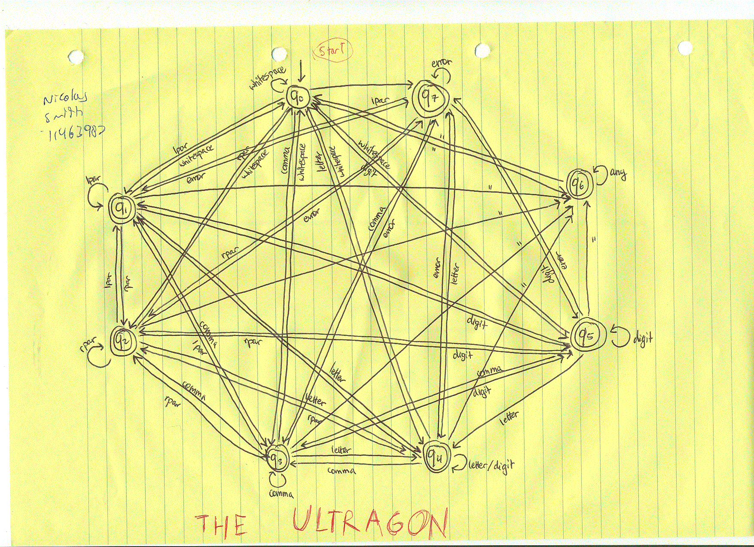

Part 3 Sample FSA input/output
Input:
tom john2 13 "hello world"
"hello/"" { joe } , 83rd 99999999999999999999 +=
Conquistador
,Finito alfredo

Output:
id 22 tom
id 281 john2
int 13
String "hello world"
String "hello""
LPar 0
id 448 joe
RPar 0
Comma 0
int 83
id 330 rd
int -1
error 0
error 0
id 478 Conquistador
Comma 0
id 353 Finito

Part 4: Jflex
Jflex is a (supposedly!) simple tool which takes a set of token definitions and rules and uses them to produce a Java Lexer. The final part of this assignment was to use this tool to create code equivalent to the Lexer we have written. Fortunately since we are dealing with a small subset of seven tokens we did not need to write reams and reams of grammar rules in our FLEX file.

I think the grammar that was written is a sufficient enough explanation of how this was implemented, regular expressions are used to define what sequences of characters form which tokens, then rules are set which do the equivalent of the returnToken() method in my Lexer.

